Chapter 11 Output and Costs

11.1 Decision Time Frames

1) The short run is a time frame in which
A) the firm is not able to hire more workers.
B) the amount of output produced is fixed.
C) there is a shortage of most factors of production.
D) at least one factor of production is fixed.
E) there is not enough time to make all of the decisions necessary to maximize profit.
Answer: D
Diff: 1 Type: MC
Topic: Decision Time Frames

2) The long run is a time frame in which
A) the firm can hire all the workers it wants to employ, but it does not have sufficient time to buy more equipment.
B) the firm is able to maximize revenue.
C) the firm may want to build a bigger plant, but cannot do so.
D) economic efficiency is achieved.
E) the quantities of all factors of production can be varied.
Answer: E
Diff: 1 Type: MC
Topic: Decision Time Frames

3) Plant refers to those factors of production
A) that are too expensive for the firm to purchase.
B) that must be held in storage for at least one year.
C) that are fixed in the short run.
D) that have a decreasing marginal product as more of the factor is used.
E) which can be purchased only in fixed quantity lots.
Answer: C
Diff: 1 Type: MC
Topic: Decision Time Frames

4) The short run refers to a time period
A) of one year or less.
B) in which all factors of production are variable.
C) in which all factors of production are fixed.
D) in which some factors of production are variable, but at least one factor of production is.
E) in which all factors of production are variable, but the technology is fixed.
Answer: D
Diff: 1 Type: MC
Topic: Decision Time Frames
Source: Study Guide
5) The long run refers to a time period
A) of one year or less.
B) in which all factors of production are variable.
C) in which labour is variable, but plant is fixed.
D) when there is at least one variable factor of production.
E) of at least 5 years.
Answer: B
Diff: 1 Type: MC
Topic: Decision Time Frames

6) Choose the correct statement.
A) The long run is a period of time in which the quantity of at least one input is fixed.
B) The short run is a period of time in which the firm has sufficient time to change all its inputs.
C) The long run is a time frame that lasts for 10 years.
D) In the short run, the firm's plant is fixed.
E) A firm always has plenty of time to make decisions about changing its inputs no matter if it is in a short run or long run position.
Answer: D
Diff: 1 Type: MC
Topic: Decision Time Frames

Use the information below to answer the following questions.

Fact 11.1.1

January 31, 2008: Starbucks will open 75 more stores abroad than originally predicted, for a total of 975.
February 25, 2008: For three hours on Tuesday, Starbucks will shut down every single one of its 7,100 stores so that baristas can receive a refresher course.
June 2, 2008: Starbucks replaces baristas with vending machines.
July 18, 2008: Starbucks is closing 616 stores by the end of March.

7) Refer to Fact 11.1.1. The decisions made on ________ are short-run decisions because they ________.
A) January 31 and July 18; change the number of stores but not necessarily the number of employees
B) February 25 and June 2; change a variable factor of production but not a fixed factor of production
C) February 25, June 2, and July 18; deal with stores located in the United States
D) June 2 and July 18; are the more recent decisions
E) None of the above.
Answer: B
Diff: 1 Type: MC
Topic: Decision Time Frames
Source: MyEconLab
8) Refer to Fact 11.1.1. The decisions made on ________ are long-run decisions because they ________.
A) June 2; are changes to labour which affect people for the long term
B) January 31 and July 18; change Starbucks' plant
C) February 25, June 2, and July 18; all deal with stores located in the United States
D) January 31 and February 25; are the earliest decisions
E) None of the above.
Answer: B
Diff: 1 Type: MC
Topic: Decision Time Frames
Source: MyEconLab

9) When the demand for electricity peaks during the hottest days of summer, Hydro One can generate more electricity by using more fuel and increasing the working hours of many of its employees. The company cannot, however, increase electric power production by building additional generating capacity. This means that the company is operating in the
A) market run.
B) intermediate run.
C) long run.
D) immediate run.
E) short run.
Answer: E
Type: MC

10) Choose the correct statement.
A) Expenditure on a plant that has no resale value is a sunk cost.
B) A sunk cost is irrelevant to a firm's current decisions.
C) A cost that influences a firm's current decisions is the short-run cost of changing its labour inputs.
D) A cost that influences a firm's current decisions is the long-run cost of changing its plant.
E) All of the above.
Answer: E
Type: MC

11.2 Short-Run Technology Constraint

1) A firm's total product curve describes
A) the minimum cost of producing a given amount of output.
B) the maximum output that a given quantity of labour can produce.
C) how the maximum attainable output varies as the size of the firm's plant varies, given the quantity of labour employed.
D) how the management of the firm makes decisions over the short run.
E) how the amount of labour varies as the amount of output varies.
Answer: B
Diff: 2 Type: MC
Topic: Short-Run Technology Constraint
2) The total product curve is a graph that shows the
A) minimum cost of producing a given amount of output using a given technology.
B) maximum profit from each unit of output sold.
C) maximum output that a given quantity of labour can produce.
D) maximum output that can be produced as technology advances.
E) change in total product for a given change in marginal product.
Answer: C
Diff: 2 Type: MC
Topic: Short-Run Technology Constraint

Use the figure below to answer the following questions.

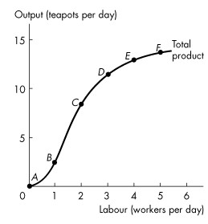
Figure 11.2.1

3) Refer to Figure 11.2.1 which illustrates Tania's total product curve. Which one of the following statements is false?
A) All the points above the curve are unattainable.
B) All the points below the curve are attainable.
C) All the points below the curve are inefficient.
D) The cost of producing at point B equals the cost of producing at point C.
E) All the points on the curve are attainable.
Answer: D
Diff: 2 Type: MC
Topic: Short-Run Technology Constraint
4) Refer to Figure 11.2.1 which illustrates Tania's total product curve. Which one of the following statements is true?
A) The points above the curve are attainable and inefficient.
B) The points below the curve are attainable and inefficient.
C) The points below the curve are inefficient and unattainable.
D) The points on the curve are efficient and unattainable.
E) Marginal product is equal at every point on the total product curve.
Answer: B
Diff: 2 Type: MC
Topic: Short-Run Technology Constraint
Source: Study Guide

5) Refer to Figure 11.2.1 which illustrates Tania's total product curve. Average product of labour reaches its maximum for the ________ worker.
A) first
B) second
C) third
D) fourth
E) fifth
Answer: B
Diff: 2 Type: MC
Topic: Short-Run Technology Constraint

6) Refer to Figure 11.2.1 which illustrates Tania's total product curve. Marginal product of labour reaches its maximum when the number of workers increases from
A) zero to 1.
B) 1 to 2.
C) 2 to 3.
D) 3 to 4.
E) 4 to 5.
Answer: B
Diff: 2 Type: MC
Topic: Short-Run Technology Constraint

7) Marginal product of labour is the increase in total product that results from a
A) one-unit increase in the quantity of labour employed, other inputs remaining the same.
B) one-unit increase in the quantity of fixed inputs employed, holding the quantity of the variable inputs constant.
C) one-unit increase in both the quantity of variable and fixed inputs.
D) change in the cost of labour.
E) 1 percent change in the quantity of labour and the quantity of capital employed.
Answer: A
Diff: 1 Type: MC
Topic: Short-Run Technology Constraint
Refer to the table below to answer the following questions.

Table 11.2.1

Labour  (workers per day) | Output  (teapots per day)
0  1  2  3  4  5 | 0  3  12  19  23  25

8) Refer to Table 11.2.1 which gives Tania's total product schedule. The marginal product when the firm increases the number of workers from 3 to 4 per day is
A) 6 teapots.
B) 2 teapots.
C) 9 teapots.
D) 7 teapots.
E) 4 teapots.
Answer: E
Diff: 2 Type: MC
Topic: Short-Run Technology Constraint

9) Refer to Table 11.2.1 which gives Tania's total product schedule. The marginal product when the number of workers increases from 1 to 2 is
A) 3 teapots.
B) 12 teapots.
C) 7 teapots.
D) 9 teapots.
E) 6 teapots.
Answer: D
Diff: 2 Type: MC
Topic: Short-Run Technology Constraint

10) Refer to Table 11.2.1 which gives Tania's total product schedule. The average product when the firm hires two workers is
A) 3 teapots per worker.
B) 6 teapots per worker.
C) 7 teapots per worker.
D) 9 teapots per worker.
E) 12 teapots per worker.
Answer: B
Diff: 2 Type: MC
Topic: Short-Run Technology Constraint
11) Refer to Table 11.2.1 which gives Tania's total product schedule. Average product of labour reaches its maximum for the ________ worker.
A) first
B) second
C) third
D) fourth
E) fifth
Answer: C
Diff: 2 Type: MC
Topic: Short-Run Technology Constraint

12) Refer to Table 11.2.1 which gives Tania's total product schedule. Marginal product of labour reaches its maximum when the number of workers increases from
A) 0 to 1.
B) 1 to 2.
C) 2 to 3.
D) 3 to 4.
E) 4 to 5
Answer: B
Diff: 2 Type: MC
Topic: Short-Run Technology Constraint

Use the table below to answer the following questions.

Table 11.2.2

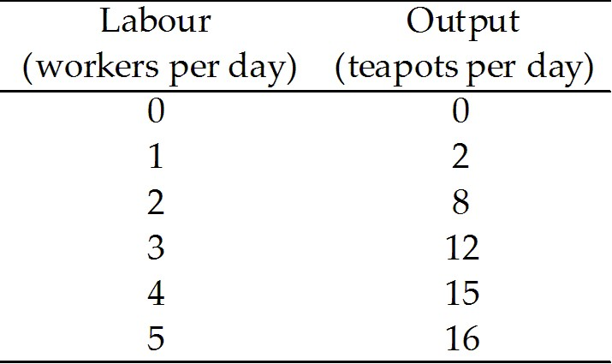

13) Refer to Table 11.2.2 which gives Tania's total product schedule. The average product when the firm employs four workers is
A) 2 teapots per worker.
B) 8 teapots per worker.
C) 12 teapots per worker.
D) 15 teapots per worker.
E) 3.75 teapots per worker.
Answer: E
Diff: 2 Type: MC
Topic: Short-Run Technology Constraint
14) Refer to Table 11.2.2 which gives Tania's total product schedule. The marginal product when the number of workers increases from 2 to 3 is
A) 1 teapot.
B) 2 teapots.
C) 3 teapots.
D) 4 teapots.
E) 3.75 teapots.
Answer: D
Diff: 2 Type: MC
Topic: Short-Run Technology Constraint

15) Refer to Table 11.2.2 which gives Tania's total product schedule. The average product when the firm hires three workers is
A) 1 teapot per worker.
B) 2 teapots per worker.
C) 3 teapots per worker.
D) 4 teapots per worker.
E) 12 teapots per worker.
Answer: D
Diff: 2 Type: MC
Topic: Short-Run Technology Constraint

16) Suppose a 1-unit increase in labour, from 2 to 3 workers, increases output from 10 to 15 tea cups. The marginal product from the increase in the quantity of labour is
A) 1 tea cup.
B) 3 tea cups.
C) 4 tea cups.
D) 5 tea cups.
E) 15 tea cups.
Answer: D
Diff: 2 Type: MC
Topic: Short-Run Technology Constraint

17) Suppose a firm increases the quantity of labour employed from 5 to 6 workers, and as a result, the firm's total output increases from 100 units to 400 units. The marginal product of the sixth worker is
A) 50 units.
B) 100 units.
C) 200 units.
D) 300 units.
E) 66.67 units.
Answer: D
Diff: 2 Type: MC
Topic: Short-Run Technology Constraint
18) Marginal product
A) is always negative.
B) is the slope of the total product curve.
C) is always zero.
D) lies between zero and one.
E) equals average product minus total product.
Answer: B
Diff: 2 Type: MC
Topic: Short-Run Technology Constraint

19) If the total product of three workers is 214 and the total product of four workers is 221, then the marginal product of the fourth worker is
A) 71.3.
B) 55.25.
C) 7.
D) 62.14.
E) 1.75.
Answer: C
Diff: 1 Type: MC
Topic: Short-Run Technology Constraint

20) If the total product of four workers is 156, calculate the average product of each worker.
A) 39
B) 19.5
C) 78
D) 152
E) 624
Answer: A
Diff: 1 Type: MC
Topic: Short-Run Technology Constraint

21) The steeper the slope of the total product curve,
A) the smaller the average product.
B) the smaller the marginal product.
C) the greater the total cost.
D) the more efficient the technology employed.
E) the greater the marginal product.
Answer: E
Diff: 2 Type: MC
Topic: Short-Run Technology Constraint
Use the figure below to answer the following question.

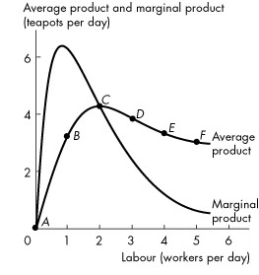
Figure 11.2.2

22) Refer to Figure 11.2.2 which shows Tania's average product curve and marginal product curve. The point of maximum average product is point
A) B.
B) C.
C) D.
D) E.
E) F.
Answer: B
Diff: 1 Type: MC
Topic: Short-Run Technology Constraint

23) Which one of the following statements is true?
A) The highest value of average product occurs where average product is greater than marginal product.
B) When the average product curve is rising, marginal product is less than average product.
C) When the average product curve is falling, marginal product is greater than average product.
D) The maximum total product occurs at minimum marginal product.
E) The highest value of average product occurs where average product equals marginal product.
Answer: E
Diff: 3 Type: MC
Topic: Short-Run Technology Constraint
24) Diminishing marginal returns refers to a situation where the ________ of an additional worker is less than the ________ of the previous worker.
A) marginal cost; marginal cost
B) average cost; average cost
C) marginal product; marginal product
D) average product; average product
E) marginal product; average product
Answer: C
Diff: 1 Type: MC
Topic: Short-Run Technology Constraint

25) The law of diminishing marginal returns states:
A) As the size of a plant increases, marginal product eventually decreases.
B) As the size of a firm's plant increases, average cost eventually decreases.
C) As a firm uses more of a variable factor of production, with a given quantity of the fixed factor of production, the marginal product of the variable factor eventually diminishes.
D) As a firm uses more of a variable factor of production, its average cost eventually decreases.
E) As a firm uses more of a variable factor or production, total product eventually decreases.
Answer: C
Diff: 1 Type: MC
Topic: Short-Run Technology Constraint

26) The law of diminishing marginal returns refers to the tendency for ________ to eventually decrease as more labour is employed, everything else remaining the same.
A) average total cost
B) marginal cost
C) total product
D) marginal product of labour
E) average product of labour
Answer: D
Diff: 1 Type: MC
Topic: Short-Run Technology Constraint

27) When the marginal product of labour is less than the average product of labour,
A) the average product of labour is increasing.
B) the marginal product of labour is increasing.
C) the total product curve is negatively sloped.
D) the firm is experiencing diminishing marginal returns.
E) None of the above.
Answer: D
Diff: 2 Type: MC
Topic: Short-Run Technology Constraint
Source: Study Guide
28) When the 7th worker is hired, output increases from 100 units per week to 110 units per week. When the 8th worker is hired, output increases from 110 units to 118 units. This is an example of
A) diminishing marginal returns.
B) diminishing marginal cost.
C) decreasing returns to scale.
D) labour-intensive production.
E) increasing returns to scale.
Answer: A
Diff: 2 Type: MC
Topic: Short-Run Technology Constraint

29) When Coffee 'n' Cream in Victoria, British Columbia hires two students, 64 customers can be served in one hour. Suppose the manager of the restaurant observes that after hiring the third student, 80 customers are being served in one hour. The marginal product of the third student is ________ customers per hour.
A) 4
B) 16
C) 8
D) 26.67
E) 32
Answer: B
Diff: 2 Type: MC
Topic: Short-Run Technology Constraint

30) When the marginal product of labour is greater than the average product of labour,
A) the average product of labour is increasing.
B) the marginal product of labour is increasing.
C) the total product curve is negatively sloped.
D) the firm is experiencing diminishing marginal returns.
E) the firm is experiencing constant returns.
Answer: A
Diff: 2 Type: MC
Topic: Short-Run Technology Constraint

Use the table below to answer the following questions.

Table 11.2.3

Labour  (workers per week) | Output  (rubbers boats per week) | Marginal Product  (rubber boats per worker) | Average Product  (rubber boats per worker)
0  1  2  3  4  5  6  7  8  9  10 | 0  1  2  4  7  11  14  16  17  18  18 | 1  1  2  A  4  B  2  1  1  0 | 1  1  C  C  2.2  E  2.28  2.13  2  1.8

31) Refer to Table 11.2.3. The value of A is
A) 1.75.
B) 2.
C) 3.
D) 7.
E) 4.
Answer: C
Diff: 2 Type: MC
Topic: Short-Run Technology Constraint

32) Refer to Table 11.2.3. The maximum value of marginal product occurs where output equals ________, while the maximum value of average product occurs where output equals ________.
A) 5; 6
B) 6; 5
C) 7; 14
D) 9; 14
E) 14; 11
Answer: D
Diff: 2 Type: MC
Topic: Short-Run Technology Constraint
Use the table below to answer the following question.

Table 11.2.4

Number of Workers | Total Product  (baskets of corn)
1  2  3  4  5 | 0  3  7  10  12

33) Refer to Table 11.2.4. The table gives the total product schedule of workers who harvest corn. Diminishing marginal returns begin when the ________ is hired.
A) 1st labourer
B) 2nd labourer
C) 3rd labourer
D) 4th labourer
E) There are no diminishing marginal returns since total product always rises.
Answer: D
Diff: 2 Type: MC
Topic: Short-Run Technology Constraint

34) Which of the following quotes best illustrates the idea of marginal product?
A) "If I have 10 workers on my assembly line, I can produce 13 tables a day."
B) "If I add an 11th worker, I can produce 1 extra table a day."
C) "Each worker produces 2 tables a day."
D) "I find if I add an extra shift at night, table production only rises by 80 percent because I need more maintenance time on the assembly line."
E) "If I double workers and double the assembly line, I can make 120 percent more tables."
Answer: B
Diff: 2 Type: MC
Topic: Short-Run Technology Constraint

35) If the marginal product of the fifth worker is 34, then the total product of five workers
A) is 35.
B) is 24.
C) is 170.
D) is 6.8.
E) cannot be calculated with the information given.
Answer: E
Diff: 2 Type: MC
Topic: Short-Run Technology Constraint
36) If capital is a variable input in a production process, the law of diminishing marginal returns implies that
A) total product is minimized.
B) capital's marginal product is positive and less than one.
C) total product is maximized.
D) marginal product of capital eventually decreases.
E) marginal product of capital is constant.
Answer: D
Diff: 2 Type: MC
Topic: Short-Run Technology Constraint

37) If energy (E) is the only input used to produce output (Q), what is the formula for average product of energy?
A) ΔQ/ΔE
B) Q/E
C) ΔE/ΔQ
D) E/Q
E) Q*E
Answer: B
Diff: 1 Type: MC
Topic: Short-Run Technology Constraint

38) If energy (E) is the only input used to produce output (Q) , what is the formula for marginal product of energy?
A) Q*E
B) Q/E
C) ΔQ/ΔE
D) ΔE/ΔQ
E) E/Q
Answer: C
Diff: 1 Type: MC
Topic: Short-Run Technology Constraint

39) Suppose the marginal product of energy equals the average product of energy. This implies that
A) marginal product is negative.
B) average product is at its maximum value.
C) marginal product is at its maximum value.
D) the marginal product curve is upward sloping.
E) average product is at its minimum value.
Answer: B
Diff: 1 Type: MC
Topic: Short-Run Technology Constraint
40) Which one of the following statements is correct?
A) When marginal product is increasing, average product is decreasing.
B) When average product is less than zero, marginal product is positive.
C) When marginal product is increasing and greater than average product, average product is increasing.
D) When marginal product is zero, total product is at its minimum.
E) When average product exceeds marginal product, marginal product is increasing.
Answer: C
Diff: 2 Type: MC
Topic: Short-Run Technology Constraint

41) Which of the following quotes best illustrates the idea of average product?
A) "If I have 10 workers on my assembly line, I can produce 13 tables a day."
B) "If I add an 11th worker, I can produce 1 extra table a day."
C) "Each worker produces 2 tables a day."
D) "I find if I add an extra shift at night, table production only rises by 80 percent because I need more maintenance time on the assembly line."
E) "If I double workers and double the assembly line, I can make 120 percent more tables."
Answer: C
Diff: 2 Type: MC
Topic: Short-Run Technology Constraint

42) Which of the following quotes best illustrates the idea of total product?
A) "If I have 10 workers on my assembly line, I can produce 13 tables a day."
B) "If I add an 11th worker, I can produce 1 extra table a day."
C) "Each worker produces 2 tables a day."
D) "I find if I add an extra shift at night, table production only rises by 80 percent because I need more maintenance time on the assembly line."
E) "If I double workers and double the assembly line, I can make 120 percent more tables."
Answer: A
Diff: 2 Type: MC
Topic: Short-Run Technology Constraint

43) The average product of labour equals
A) the slope of the total product curve.
B) the slope of the marginal product curve.
C) the increase in total product divided by the increase in labour employed.
D) total product divided by the quantity of labour employed.
E) the difference between the total product and the marginal product of labour.
Answer: D
Diff: 1 Type: MC
Topic: Short-Run Technology Constraint
Source: Study Guide
44) The average product of energy equals
A) the increase in total product divided by the increase in energy used.
B) total product divided by the quantity of energy used.
C) the slope of the total product curve.
D) the slope of the marginal product curve.
E) the difference between the total product and the marginal product of energy.
Answer: B
Diff: 1 Type: MC
Topic: Short-Run Technology Constraint

45) Which of the following statements by a restaurant owner refers to the law of diminishing marginal returns?
A) "The higher the quality of the ingredients we use, the higher the cost of producing each meal."
B) "If we double the size of our premises and double everything else — kitchen staff, serving staff, equipment — we can increase the number of meals we serve, but not to double the current levels."
C) "We can increase the number of meals we serve by just adding more kitchen staff, but each additional worker adds less meals than the previous worker because traffic in the kitchen will get worse."
D) "We can serve the same number of meals with fewer kitchen staff, but we would have to buy more labour-saving kitchen equipment."
E) "We can serve the same number of meals with less kitchen equipment, but we would have to hire more kitchen staff."
Answer: C
Diff: 3 Type: MC
Topic: Short-Run Technology Constraint
Source: Study Guide

46) Choose the correct statement.
A) When marginal product of labour is greater than average product of labour and marginal product is either increasing or decreasing average product of labour is increasing.
B) When total product is increasing average product of labour and marginal product of labour are both increasing.
C) When marginal product of labour is greater than or equal to average product of labour, average product of labour is increasing.
D) When marginal product of labour is increasing, average product of labour is greater than marginal product of labour.
E) When total product is increasing, average product of labour is decreasing and marginal product of labour is increasing.
Answer: A
Diff: 3 Type: MC
Topic: Short-Run Technology Constraint
Source: MyEconLab
47) The marginal product of labour initially ________ and eventually ________. The average product of labour initially ________ and eventually ________.
A) increases; decreases; increases; decreases
B) decreases; increases; decreases; increases
C) increases; decreases; decreases; increases
D) decreases; increases; increases; decreases
E) increases; is constant; increases; decreases
Answer: A
Diff: 3 Type: MC
Topic: Short-Run Technology Constraint
Source: MyEconLab

48) The total output produced with any quantity of labour is equal to the sum of the
A) average products of each of the workers hired.
B) marginal costs of each of the workers hired.
C) marginal products of each of the workers hired.
D) average costs of each of the workers hired.
E) fixed products of each of the workers hired.
Answer: C
Type: MC

49) The average product of labour is
A) the inverse of the average product of capital.
B) the slope of the marginal product of labour curve.
C) the slope of the total product curve.
D) greater than the average product of labour.
E) calculated as total product divided by the total quantity of labour employed.
Answer: E
Type: MC

50) At that amount of output where diminishing marginal returns first sets in,
A) average product begins to decrease.
B) total product begins to decrease.
C) marginal cost begins to decrease.
D) marginal product begins to decrease.
E) All of the above.
Answer: D
Type: MC
11.3 Short-Run Cost

1) Which of the following are correct? According to the law of diminishing returns,
(1) marginal product eventually rises.
(2) marginal product eventually falls.
(3) marginal cost eventually rises.
(4) marginal cost eventually falls.
A) (1) and (3)
B) (1) and (4)
C) (2) and (3)
D) (2) and (4)
E) (4)
Answer: C
Diff: 2 Type: MC
Topic: Short-Run Cost
Source: Study Guide

Use the table below to answer the following questions.

Table 11.3.1

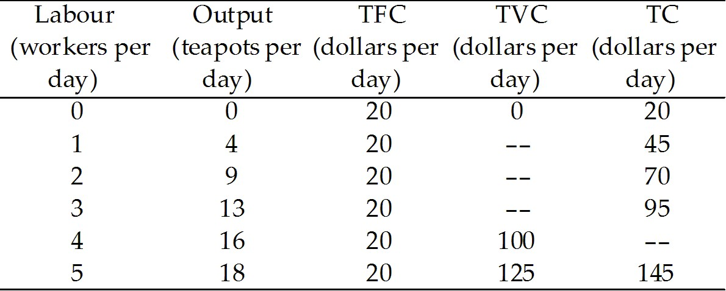

2) Refer to Table 11.3.1, which gives Tania's total cost schedule. The average fixed cost of producing 9 teapots per day is
A) $2.22.
B) $1.25.
C) $10.00.
D) $1.11.
E) $1.54.
Answer: A
Diff: 2 Type: MC
Topic: Short-Run Cost

3) Refer to Table 11.3.1, which gives Tania's total cost schedule. The average total cost of producing 16 teapots per day is
A) $2.
B) $5.
C) $3.33.
D) $7.50.
E) $5.51.
Answer: D
Diff: 2 Type: MC
Topic: Short-Run Cost
4) Refer to Table 11.3.1, which gives Tania's total cost schedule. When output increases from 4 to 9 teapots, the marginal cost of one of the 5 teapots is
A) $4.25.
B) $4.
C) $25.
D) $6.25.
E) $5.
Answer: E
Diff: 2 Type: MC
Topic: Short-Run Cost

Use the table below to answer the following questions.

Table 11.3.2

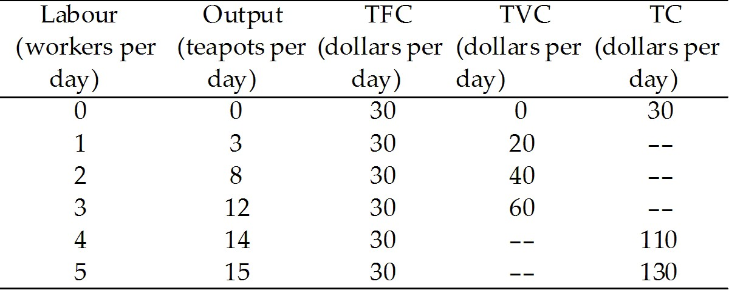

5) Refer to Table 11.3.2, which gives Tania's total cost schedule. The average total cost of producing 14 teapots is
A) $7.86.
B) $6.75.
C) $7.
D) $1.75.
E) $27.50.
Answer: A
Diff: 2 Type: MC
Topic: Short-Run Cost

6) Refer to Table 11.3.2, which gives Tania's total cost schedule. When output increases from 8 to 12 teapots, the marginal cost of one of the 4 teapots is
A) $20.
B) $5.
C) $1.
D) $6.67.
E) $2.
Answer: B
Diff: 2 Type: MC
Topic: Short-Run Cost
7) If an increase in output from 5 to 10 teapots increases total cost from $100 to $200, the marginal cost of one of those 5 teapots is
A) $10.
B) $20.
C) $22.
D) $25.
E) dependent upon the amount of extra labour used.
Answer: B
Diff: 2 Type: MC
Topic: Short-Run Cost

8) Marginal cost is equal to
A) total cost divided by output.
B) the increase in total cost divided by the increase in output.
C) the increase in total cost divided by the increase in labour input, given the amount of capital.
D) total variable cost minus total fixed cost.
E) the increase in total cost divided by the increase in variable cost.
Answer: B
Diff: 1 Type: MC
Topic: Short-Run Cost

9) Choose the correct equation.
A) TFC=TC/Q
B) TFC=TC-AVC
C) TFC=TC-TVC
D) TFC=TVC/Q
E) TFC=TVC-TC
Answer: C
Diff: 1 Type: MC
Topic: Short-Run Cost

10) Which one of the following statements is false?
A) Average total cost is total cost per unit of output.
B) Average fixed cost plus average variable cost equals average total cost.
C) Marginal cost is the increase in total cost resulting from a one-unit increase in output.
D) Total cost equals fixed cost plus average cost.
E) Marginal cost depends on the amount of labour hired.
Answer: D
Diff: 2 Type: MC
Topic: Short-Run Cost

11) Which one of the following statements is false?
A) Total variable cost plus total fixed cost equals total cost.
B) Marginal cost equals the change in total cost divided by the change in output.
C) Average total cost is calculated by dividing total cost by the level of output.
D) The average cost curve is U-shaped.
E) The total cost curve is U-shaped.
Answer: E
Diff: 2 Type: MC
Topic: Short-Run Cost
12) Which one of the following statements is false?
A) The average total cost curve and average variable cost curve are U-shaped.
B) The gap between the average total cost curve and the average variable cost curve equals marginal cost.
C) The gap between the average total cost curve and the average variable cost curve narrows as output increases.
D) The marginal cost curve intersects the average variable cost curve at minimum average variable cost.
E) The marginal cost curve intersects the average total cost curve at minimum average total cost.
Answer: B
Diff: 2 Type: MC
Topic: Short-Run Cost

Use the figure below to answer the following question.

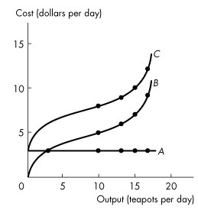
Figure 11.3.1

13) Refer to Figure 11.3.1. Which one of the following statements is false?
A) The total fixed cost curve A.
B) Total variable cost and total cost both increase with output.
C) The vertical gap between curves B and C is equal to total variable cost.
D) Marginal cost is equal to the slope of curve C.
E) Total fixed cost is constant.
Answer: C
Diff: 2 Type: MC
Topic: Short-Run Cost
Use the figure below to answer the following questions.

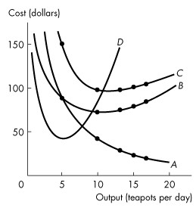
Figure 11.3.2

14) Refer to Figure 11.3.2, which illustrates short-run average and marginal cost curves. Which one of the following statements is false?
A) Average fixed cost decreases with output.
B) The vertical gap between curves B and C is equal to average variable cost.
C) Line B comes closer to line C as output increases because of a decrease in average fixed cost.
D) Curve D is the marginal cost curve.
E) The vertical gap between curves B and C is equal to average fixed cost.
Answer: B
Diff: 2 Type: MC
Topic: Short-Run Cost

15) Refer to Figure 11.3.2, which illustrates the short-run average and marginal cost curves. The average variable cost curve is curve
A) A.
B) B.
C) C.
D) D.
E) none of the above.
Answer: B
Diff: 1 Type: MC
Topic: Short-Run Cost
16) Refer to Figure 11.3.2, which illustrates the short-run average and marginal cost curves. The marginal cost curve is curve
A) A.
B) B.
C) C.
D) D.
E) none of the above.
Answer: D
Diff: 1 Type: MC
Topic: Short-Run Cost

17) Which one of the following is false?
A) The marginal cost curve intersects the average variable cost curve and the average total cost curve at their maximum points.
B) When marginal cost is greater than average variable cost, average variable cost is increasing.
C) When marginal cost is greater than average total cost, average total cost is increasing.
D) The average total cost curve is U-shaped.
E) The average fixed cost curve is downward sloping.
Answer: A
Diff: 2 Type: MC
Topic: Short-Run Cost

18) As soon as diminishing returns set in, a firm's
A) marginal product increases.
B) average fixed cost decreases.
C) marginal cost decreases.
D) marginal cost increases.
E) total cost decreases.
Answer: D
Diff: 2 Type: MC
Topic: Short-Run Cost

19) Average variable cost is at a minimum at the same output at which
A) average product is at a maximum.
B) average product is at a minimum.
C) marginal product is at a maximum.
D) marginal product is at a minimum.
E) marginal cost is at a minimum.
Answer: A
Diff: 2 Type: MC
Topic: Short-Run Cost
Source: Study Guide
20) The range over which average variable cost is decreasing is the same as the range over which
A) marginal cost is increasing.
B) average fixed cost is decreasing.
C) marginal product is decreasing.
D) average product is decreasing.
E) average product is increasing.
Answer: E
Diff: 2 Type: MC
Topic: Short-Run Cost

21) The vertical distance between the TC and TVC curves
A) decreases as output increases.
B) increases as output increases.
C) is equal to AFC.
D) is equal to TFC.
E) is equal to MC.
Answer: D
Diff: 2 Type: MC
Topic: Short-Run Cost
Source: Study Guide

22) The marginal cost (MC) curve intersects the
A) ATC, AVC, and AFC curves at their minimum points.
B) ATC and AFC curves at their minimum points.
C) AVC and AFC curves at their minimum points.
D) ATC and AVC curves at their minimum points.
E) TC and TVC curves at their minimum points.
Answer: D
Diff: 2 Type: MC
Topic: Short-Run Cost
Source: Study Guide

23) If the average variable cost of producing 10 units is $18 and the average variable cost of producing 11 units is $20, we know that, between 10 and 11 units of output,
A) marginal cost is increasing.
B) average total cost is increasing.
C) average fixed cost is increasing.
D) total cost is either increasing or decreasing.
E) none of the above.
Answer: A
Diff: 3 Type: MC
Topic: Short-Run Cost
24) Marginal cost is the amount that
A) total cost increases when one more labourer is hired.
B) fixed cost increases when one more labourer is hired.
C) variable cost increases when one more labourer is hired.
D) total cost increases when one more unit of output is produced.
E) fixed cost increases when one more unit of output is produced.
Answer: D
Diff: 1 Type: MC
Topic: Short-Run Cost
Source: Study Guide

25) Marginal cost equals
A) Q/TVC.
B) ΔTFC/ΔTC.
C) ΔTC/ΔQ.
D) ΔQ/ΔTVC.
E) (TC-TVC)/Q.
Answer: C
Diff: 1 Type: MC
Topic: Short-Run Cost

26) Marginal cost equals
A) TC/Q.
B) Q/TVC.
C) (TC-TVC)/Q.
D) TC/ΔQ.
E) ΔTC/ΔQ.
Answer: E
Diff: 1 Type: MC
Topic: Short-Run Cost

27) Given an upward-sloping, straight line total variable cost curve, what does the marginal cost curve look like?
A) an upward-sloping straight line
B) a downward-sloping straight line
C) a U-shaped curve
D) a horizontal line
E) a vertical line
Answer: D
Diff: 1 Type: MC
Topic: Short-Run Cost

28) A rise in the price of a fixed input shifts a firm's
A) average variable cost curve upward.
B) average total cost curve upward.
C) average total cost curve downward.
D) marginal cost curve upward.
E) marginal cost curve downward.
Answer: B
Diff: 2 Type: MC
Topic: Short-Run Cost
Source: Study Guide
29) Total cost is $20 at 4 units of output and $36 at 6 units of output. Between 4 and 6 units of output, marginal cost
A) is less than average total cost.
B) is equal to average total cost.
C) is equal to average variable cost.
D) is greater than average total cost.
E) equals average fixed cost.
Answer: D
Diff: 3 Type: MC
Topic: Short-Run Cost
Source: Study Guide

30) A firm's total fixed cost is $100. If total cost is $200 for one unit of output and $310 for two units, what is the marginal cost of the second unit?
A) $100
B) $110
C) $200
D) $210
E) $310
Answer: B
Diff: 2 Type: MC
Topic: Short-Run Cost
Source: Study Guide

31) If ATC is falling, then MC must be
A) rising.
B) falling.
C) equal to ATC.
D) above ATC.
E) below ATC.
Answer: E
Diff: 2 Type: MC
Topic: Short-Run Cost
Source: Study Guide

32) If ATC is rising then MC must be
A) rising.
B) falling.
C) equal to ATC.
D) above ATC.
E) both A and D.
Answer: E
Diff: 2 Type: MC
Topic: Short-Run Cost
33) If AFC is falling then MC must be
A) rising.
B) falling.
C) above AFC.
D) below AFC.
E) none of the above.
Answer: E
Diff: 2 Type: MC
Topic: Short-Run Cost

34) If MC is rising then ATC must be
A) rising.
B) falling.
C) above MC.
D) below MC.
E) none of the above.
Answer: E
Diff: 3 Type: MC
Topic: Short-Run Cost

35) Which of the following quotes best illustrates the idea of fixed cost?
A) "As we increase output, per-unit costs fall."
B) "My primary source of overhead cost is the cost of running the head office."
C) "If I need to, I can negotiate more overtime with my work force to meet unexpected orders."
D) "If I double the number of workers and trucks, I get only 80 percent more packages delivered."
E) None of the above.
Answer: B
Diff: 2 Type: MC
Topic: Short-Run Cost

36) The ATC curve shifts upward if
A) factor prices rise.
B) a new technology is introduced.
C) more workers are hired.
D) all of the above.
E) none of the above.
Answer: A
Diff: 2 Type: MC
Topic: Short-Run Cost

37) The MC curve shifts upward if
A) factor prices rise.
B) a new technology is introduced.
C) more workers are hired.
D) all of the above.
E) none of the above.
Answer: A
Diff: 2 Type: MC
Topic: Short-Run Cost
38) The AFC curve shifts upward if
A) factor prices rise.
B) a new technology is introduced.
C) more workers are hired.
D) all of the above.
E) none of the above.
Answer: E
Diff: 2 Type: MC
Topic: Short-Run Cost

39) The marginal cost curve slopes upward due to
A) diminishing marginal utility.
B) diminishing marginal returns.
C) technological inefficiency.
D) economic inefficiency.
E) none of the above.
Answer: B
Diff: 2 Type: MC
Topic: Short-Run Cost

40) The average fixed cost curve slopes downward due to
A) diminishing marginal utility.
B) diminishing marginal returns.
C) technological inefficiency.
D) economic inefficiency.
E) none of the above.
Answer: E
Diff: 2 Type: MC
Topic: Short-Run Cost

41) The average variable cost curve will shift upward if
A) there is an increase in fixed cost.
B) there is a technological advance.
C) the price of the variable input decreases.
D) the price of the variable input increases.
E) the price of output increases.
Answer: D
Diff: 2 Type: MC
Topic: Short-Run Cost
Source: Study Guide
42) A technological advance will shift
(1) TP, AP, and MP curves up.
(2) TP, AP, and MP down.
(3) TC, ATC, and MC curves up.
(4) TC, ATC, and MC curves down.
A) (1) and (3)
B) (1) and (4)
C) (2) and (3)
D) (2) and (4)
E) none of the above
Answer: B
Diff: 2 Type: MC
Topic: Short-Run Cost
Source: Study Guide

43) An increase in the cost of labour shifts the
A) total, average, and marginal product curves upward and total, average, and marginal cost curves upward.
B) total, average, and marginal product curves upward and total, average, and marginal cost curves downward.
C) total, average, and marginal product curves downward and total, average, and marginal cost curves upward.
D) total, average, and marginal product curves downward and total, average, and marginal cost curves downward.
E) none of the above.
Answer: E
Diff: 2 Type: MC
Topic: Short-Run Cost

44) Marginal cost ________.
A) is constantly increasing, but as output increases it increases by smaller and smaller amounts
B) decreases at low outputs until it reaches its minimum value, then remains constant
C) decreases at low outputs and increases at high outputs
D) increases at low outputs until it reaches its maximum value, then remains constant
E) is constantly decreasing, but as output increases it decreases by smaller and smaller amounts
Answer: C
Diff: 2 Type: MC
Topic: Short-Run Cost
Source: MyEconLab
45) The marginal cost curve slopes downward at low outputs because of ________. The marginal cost curve eventually slopes upward because of ________.
A) greater specialization and division of labour; the law of diminishing returns
B) the law of diminishing returns; increasing average fixed cost
C) falling average fixed cost; the law of diminishing returns
D) the law of diminishing returns; greater specialization and division of labour
E) greater specialization and division of labour; rising average fixed cost
Answer: A
Diff: 2 Type: MC
Topic: Short-Run Cost
Source: MyEconLab

46) When the marginal product curve is ________, the marginal cost curve is falling. When the average product curve is ________, the average variable cost curve is falling. Maximum MP occurs at the same output as ________. Maximum AP occurs at the same output as ________.
A) rising; rising; maximum MC; maximum AVC
B) falling; falling; minimum MC; minimum AVC
C) rising; rising; minimum MC; minimum AVC
D) falling; falling; maximum MC; maximum AVC
E) rising; rising; minimum MC; minimum ATC
Answer: C
Diff: 2 Type: MC
Topic: Short-Run Cost
Source: MyEconLab

47) Sue's Surfboards rents the factory building in which it produces surfboards. The rent is increased by $200 a week. If other things remain the same, the average fixed cost curve ________, the average variable cost curve ________, the average total cost curve ________, and the marginal cost curve ________.
A) does not change; shifts upward; shifts upward; shifts upward
B) shifts upward; does not change; shifts upward; does not change
C) shifts upward; does not change; does not change; shifts upward
D) shifts upward; does not change; shifts upward; shifts upward
E) shifts upward; shifts upward; shifts upward; shifts upward
Answer: B
Diff: 2 Type: MC
Topic: Short-Run Cost
Source: MyEconLab

48) Which type of cost does not change as the quantity of output produced changes?
A) average total cost
B) marginal cost
C) average fixed cost
D) total fixed cost
E) Both C and D are correct.
Answer: D
Type: MC
49) Ernie's Earmuffs produces 200 earmuffs per year at a total cost of $2,000 and $400 of this cost is fixed. What is Ernie's total variable cost?
A) $400
B) $8
C) $2
D) $2,400
E) $1,600
Answer: E
Type: MC

50) Ernie's Earmuffs produces 200 earmuffs per year at a total cost of $2,000 and $400 of this cost is fixed. What is Ernie's average variable cost?
A) $400
B) $8
C) $2
D) $2,400
E) $1,600
Answer: B
Type: MC

11.4 Long-Run Cost

1) A production function is the relationship between the maximum output attainable and the
A) price of output.
B) change in technology.
C) demand for output.
D) quantities of inputs used.
E) amount of labour used.
Answer: D
Diff: 1 Type: MC
Topic: Long-Run Cost
Use the figure below to answer the following questions.

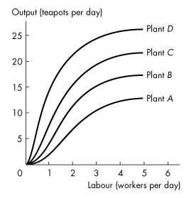
Figure 11.4.1

2) Refer to Figure 11.4.1 which shows the total product curves for four different plant sizes as Tania varies the quantity of capital and workers. The curve that represents the plant using the largest amount of capital is
A) plant A.
B) plant B.
C) plant C.
D) plant D.
E) all curves because each plant uses the same number of machines, just different amounts of labour.
Answer: D
Diff: 2 Type: MC
Topic: Long-Run Cost

3) Refer to Figure 11.4.1, which illustrates the total product curves for four different plant sizes. One of the fundamental technological facts reflected in the shape of each of the total product curves is the
A) price of the inputs.
B) price of the output.
C) law of diminishing marginal returns.
D) law of economies of scale.
E) fact that capital and labour cannot be substituted for each other.
Answer: C
Diff: 2 Type: MC
Topic: Long-Run Cost
4) The marginal product of capital is the
A) change in total product resulting from a 1-unit increase in the quantity of labour employed, holding the quantity of the capital constant.
B) change in total product resulting from a 1-unit increase in the quantity of capital employed, holding the quantity of the labour constant.
C) total product divided by the total quantity of capital employed, holding the quantity of the labour constant.
D) total product divided by the total quantity of labour employed, holding the quantity of the capital constant.
E) change in the quantity of capital used resulting from a 1-unit increase in total product, holding constant the quantity of labour.
Answer: B
Diff: 2 Type: MC
Topic: Long-Run Cost

5) Suppose Honda can triple its production of Civics by tripling its production facility for those cars. This indicates the presence of
A) constant returns to scale.
B) economies of scale.
C) diseconomies of scale.
D) the law of diminishing returns.
E) minimum efficient scale.
Answer: A
Diff: 2 Type: MC
Topic: Long-Run Cost

6) Suppose a candy manufacturer can triple its production of fudge by doubling its production facility for making fudge. This indicates the presence of
A) constant returns to scale.
B) economies of scale.
C) diseconomies of scale.
D) market constraints.
E) the law of diminishing returns.
Answer: B
Diff: 2 Type: MC
Topic: Long-Run Cost

7) Diseconomies of scale are present when
A) the LRAC curve slopes downward.
B) average total cost falls as input increases.
C) average total cost rises as output increases.
D) the LRAC curve is horizontal.
E) total fixed cost increases.
Answer: C
Diff: 1 Type: MC
Topic: Long-Run Cost
8) Economies of scale are present when
A) the LRAC curve slopes downward.
B) average total cost remains constant as input increases.
C) average total cost rises as output increases.
D) the LRAC curve is horizontal.
E) total fixed cost increases.
Answer: A
Diff: 1 Type: MC
Topic: Long-Run Cost

9) If diseconomies of scale are present
A) average total cost is decreasing.
B) the long-run average cost curve has a negative slope.
C) economies of scale are also present.
D) the long-run average cost curve has a positive slope.
E) None of the above.
Answer: D
Diff: 2 Type: MC
Topic: Long-Run Cost

10) If constant returns to scale are present
A) average total cost is decreasing.
B) average total cost is increasing.
C) the LRAC curve is horizontal.
D) the LRAC curve is downward sloping.
E) the LRAC curve is upward sloping.
Answer: C
Diff: 2 Type: MC
Topic: Long-Run Cost
Use the table below to answer the following questions.

Table 11.4.1
Swanky's output levels

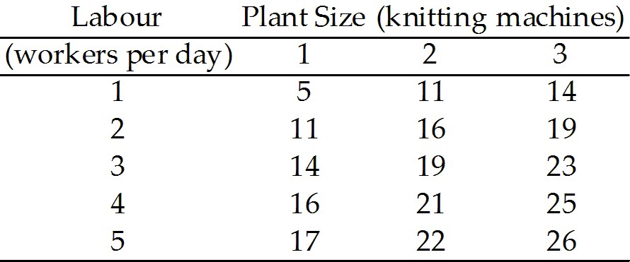

11) Refer to Table 11.4.1, which represents Swanky's production possibilities as the firm varies the quantities of knitting machines and workers per day. If Swanky increases the number of knitting machines from 2 to 3 and increases the number of workers employed from 2 to 3, the factory experiences
A) economies of scale.
B) constant returns to scale.
C) diseconomies of scale.
D) constant marginal product.
E) minimum efficient scale.
Answer: C
Diff: 3 Type: MC
Topic: Long-Run Cost

12) Refer to Table 11.4.1, which represents Swanky's production possibilities as the firm varies the quantities of knitting machines and workers per day. If Swanky increases the number of knitting machines from 1 to 2 and increases the number of workers employed from 1 to 2, the factory experiences
A) economies of scale.
B) constant returns to scale.
C) diseconomies of scale.
D) constant marginal product.
E) minimum efficient scale.
Answer: A
Diff: 3 Type: MC
Topic: Long-Run Cost
Use the figure below to answer the following questions.

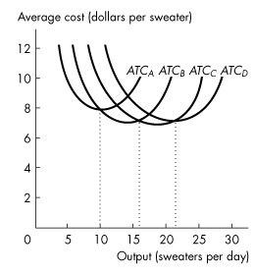
Figure 11.4.2

13) Refer to Figure 11.4.2, which illustrates the short-run average total cost curves for four different plant sizes. Which curve represents the average total cost for the largest of the four plant sizes?
A) ATCA
B) ATCB
C) ATCC
D) ATCD
E) either ATCC or ATCD
Answer: D
Diff: 3 Type: MC
Topic: Long-Run Cost

14) Refer to Figure 11.4.2, which illustrates the short-run average total cost curves for four different plant sizes. Which plant has the lowest average total cost for an output rate of 5 sweaters a day?
A) Plant A
B) Plant B
C) Plant C
D) Plant D
E) none of the above
Answer: A
Diff: 3 Type: MC
Topic: Long-Run Cost
Use the figure below to answer the following question.

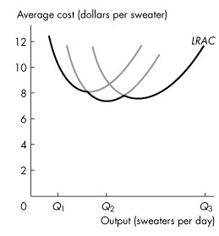
Figure 11.4.3

15) Refer to Figure 11.4.3 which shows a firm's long-run average total cost curve. An increase in production from Q1 to Q2 sweaters per day produces
A) the minimum efficient scale.
B) economies of scale.
C) diseconomies of scale.
D) constant total costs.
E) constant returns to scale.
Answer: B
Diff: 2 Type: MC
Topic: Long-Run Cost
Use the figure below to answer the following questions.

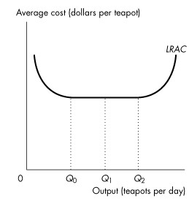
Figure 11.4.4

16) Refer to Figure 11.4.4, which illustrates the long-run average total cost curve. Which one of the following statements is false?
A) Economies of scale exist between 0 and Q0 units of output.
B) Diseconomies of scale exist between 0 and Q1 units of output.
C) Constant returns to scale exist between Q1 and Q2 units of output.
D) Diseconomies of scale exist at quantities greater than Q2 units of output.
E) Constant returns to scale exist between Q0 and Q1 units of output.
Answer: B
Diff: 2 Type: MC
Topic: Long-Run Cost

17) Refer to Figure 11.4.4, which illustrates the long-run average total cost curve. Given an increase in output from Q1 to Q2,
A) economies of scale exist.
B) diseconomies of scale exist.
C) constant returns to scale exist.
D) average total cost is increasing.
E) average total cost is decreasing.
Answer: C
Diff: 2 Type: MC
Topic: Long-Run Cost
18) A firm will want to increase its scale of plant if
A) it is persistently producing on the upward-sloping part of its short-run average total cost curve.
B) it is persistently producing on the downward-sloping part of its short-run average total cost curve.
C) it is producing below minimum efficient scale.
D) marginal cost is below average total cost.
E) marginal cost is below average variable cost.
Answer: A
Diff: 3 Type: MC
Topic: Long-Run Cost
Source: Study Guide

19) The minimum efficient scale is the smallest quantity of output at which
A) the long-run average cost curve reaches its lowest level.
B) the average total cost curve reaches its lowest level.
C) the average fixed cost curve reaches its lowest level.
D) economies of scale begin.
E) diminishing returns begin.
Answer: A
Diff: 2 Type: MC
Topic: Long-Run Cost
Source: Study Guide

20) Diminishing returns to capital ________ occur as the quantity of capital increases because for a given quantity of ________ each additional unit of ________ will result in ________ incremental amounts of output.
A) do not; capital; labour; greater
B) do; labour; capital; smaller
C) do not; labour; capital; greater
D) do; capital; labour; smaller
E) do not; labour; capital; smaller
Answer: B
Diff: 2 Type: MC
Topic: Long-Run Cost
Source: MyEconLab

21) The long-run average cost curve is the relationship between the lowest attainable average total cost and output, when plant size is ________ and labour is ________. The long-run average cost curve is made up of the segments of individual average ________ cost curves with the lowest average ________ cost for a given output.
A) varied; varied; variable; variable
B) varied; varied; total; total
C) varied; held constant; variable; variable
D) held constant; varied; total; total
E) held constant; varied; variable; variable
Answer: B
Diff: 2 Type: MC
Topic: Long-Run Cost
Source: MyEconLab
22) Economies of scale refer to the range of output over which
A) long-run average cost rises as output increases.
B) marginal cost exceeds average cost.
C) long-run average cost falls as output increases.
D) the marginal product of labour decreases.
E) marginal product equals average product.
Answer: C
Type: MC

23) Diseconomies of scale refer to the range of output over which
A) long-run average cost rises as output increases.
B) average cost exceeds marginal cost.
C) long-run average cost falls as output increases.
D) the marginal product of labour increases.
E) marginal product equals average product.
Answer: A
Type: MC

